Program 24-

P1-

<html>

<head>

<title>program 24</title>

</head>

<body style="background-color:black;">

<center>

<a href="program2.html">

<img src=" thumb-1920-345366.jpg" width="700" height="300"/>

</a>

<font size=6px>

<p style="color:white";>Click Image</p>

</font>

</center>

</body>

Output-

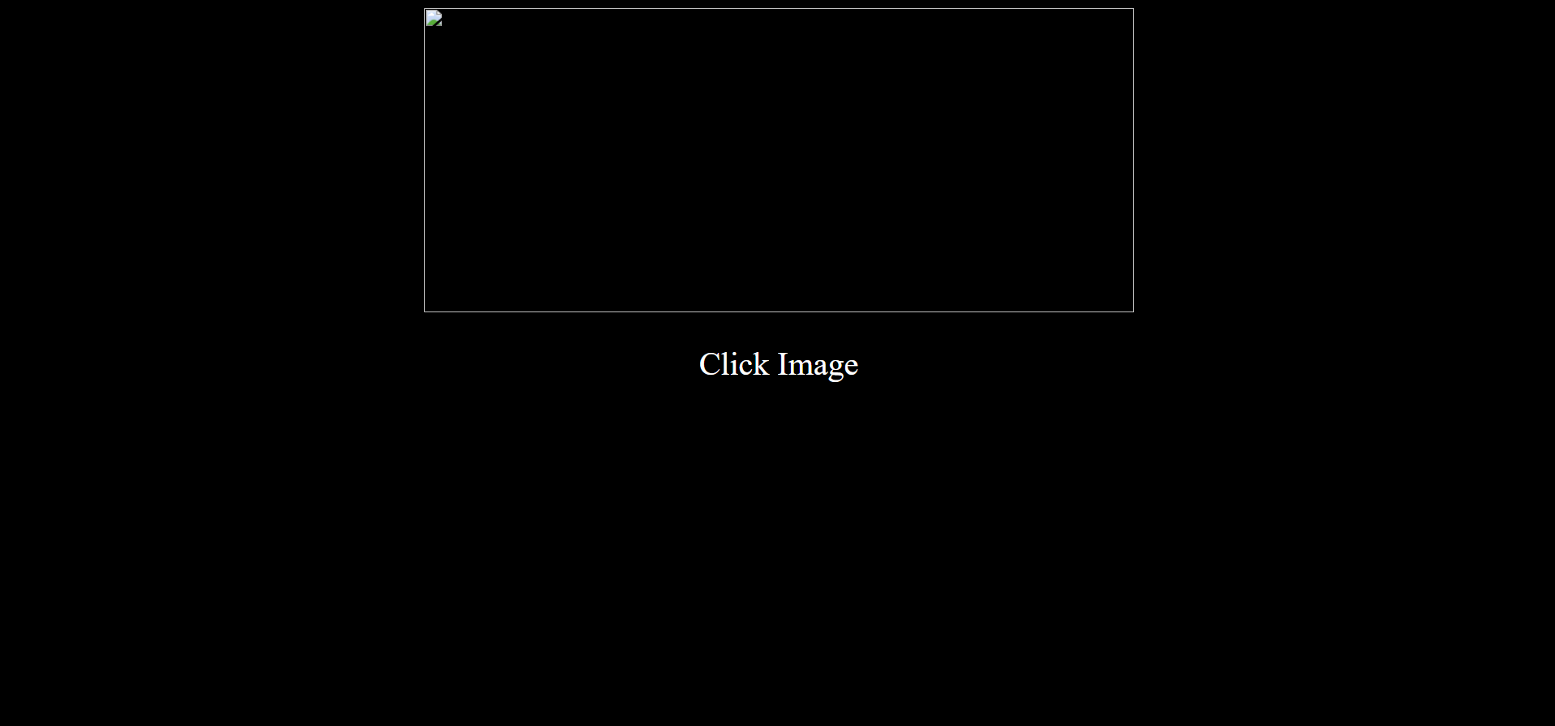

P2-

<html>

<head>

<title>Another HTML Page</title>

</head>

<body>welcome to HTML page</body>

</html>

Output-

